

LAB NO.

**____4___**

|  |  |
| --- | --- |
| TASK NO | OBJECTIVE |
| 1 | Make a Calculator! using prompt(), and variables, make a program that does the following:  i Prompts the user for first number.  ii Stores that first number  iii Prompts the user for the second number  Iv Asks which operation does it want to perform (+,-,/,*,++,--,%)  V Stores that result and responds with the calculated value by using an alert. |
| 2 | using this array  var array = ["Banana", "Apples", "Oranges", "Blueberries"];  1. Remove the Banana from the array.  2. Sort the array in order.  3. Put "Kiwi" at the end of the array.  4. Remove "Apples" from the array.  5. Sort the array in reverse order. (Not alphabetical, but reverse// the current Array i.e. ['a', 'c', 'b'] becomes ['b', 'c', 'a']) |
| 3 | Alarm ringing !  I Suppose by default there is a prompt saying “ Alarm is ringing”. Press ‘S’ to snooze and ‘D’ to dismiss  II If user selects ‘D’, program will be dismissed with a prompt “Good Morning”  III If user select ‘S’ , the program “ Alarm is ringing”. Press ‘S’ to snooze and ‘D’ to dismiss will rerun and again the prompt will be (repeat from step I)  IV upon entering wrong input program will prompt “wrong input” and program ends. |
| 4 | Create an object and an array which we will use in our facebook exercise.  Create an object that has properties "username" and "password". Fill those values in with strings.  Create an array which contains the object you have made above and name the array "database".  Create an array called "newsfeed" which contains 3 objects with properties "username" and "timeline". |

Submitted On:

8-4-22

**Task 1:**

Code:

const operator = prompt('Enter operator ( either +, -, * or / ): ');

const number1 = parseFloat(prompt('Enter first number: '));

const number2 = parseFloat(prompt('Enter second number: '));

let result;

if (operator == '+') {

result = number1 + number2;

}

else if (operator == '-') {

result = number1 - number2;

}

else if (operator == '*') {

result = number1 * number2;

}

else {

result = number1 / number2;

}

console.log(`${number1} ${operator} ${number2} = ${result}`);

Output:

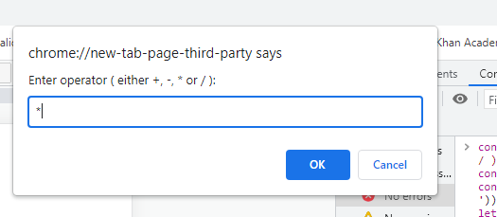

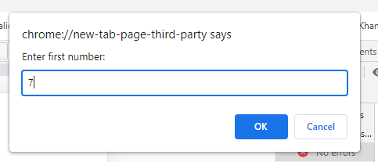

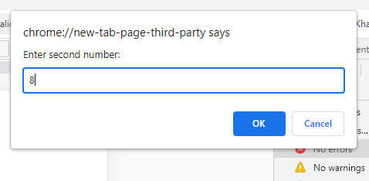

**Task 2:**

1. Remove the Banana from the array.

2. Sort the array in order.

3. Put "Kiwi" at the end of the array.

4. Remove "Apples" from the array.

5. Sort the array in reverse order.

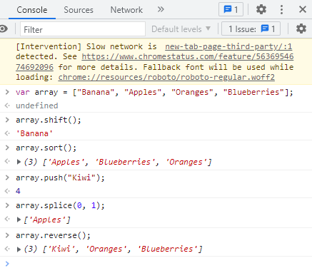

**Task 3:**

Code:

<body>

    <p>Click the button</p>

    <button onclick="myFunction()">Try it</button>

    <p id="msg"></p>

    <script>

        function myFunction() {

            let myAlarm = prompt("Alarm is ringing//Press S to snooze and D to dismiss");

            if (myAlarm == "S") {

                myFunction();

            }

            else if (myAlarm == "D") {

                document.getElementById("msg").innerHTML = "Good Morning";

            }

            else {

                document.getElementById("msg").innerHTML = "Wrong Input Program Ended";

            }

        }

    </script>

    </body>

Output:

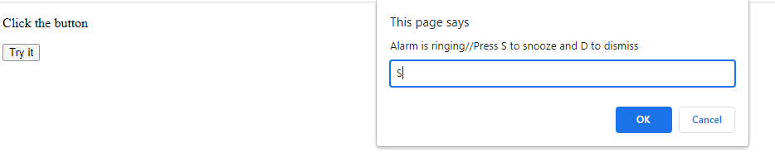

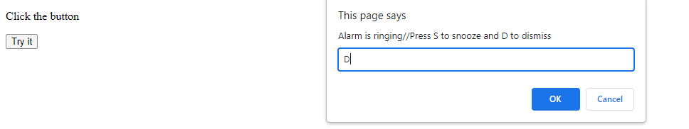

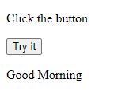

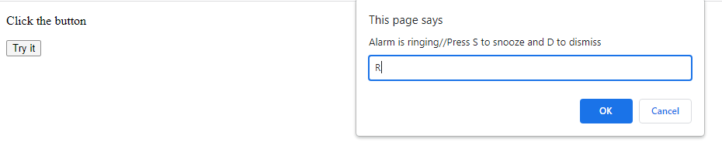

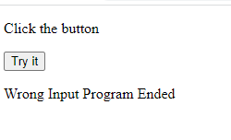

**Task 4:**

* Create an object that has properties "username" and "password". Fill those values in with strings.

**Solution:**

var myObj = {

username : "humza",

password : "hello"

}

* Create an array which contains the object you have made above and name the array "database".

**Solution:**

var database = [

{

username : "humza",

password : "hello"

}

];

* Create an array called "newsfeed" which contains 3 objects with properties "username" and "timeline".

**Solution:**

var newsfeed = [

{

username : "humza",

timeline : "bye"

},

{

username : "ali",

timeline : "classic"

},

{

username : "ahmed",

timeline : "old"

}

]